Aug 08, 2022

Paveethran Swaminathan

Department of Computer Science

Indiana University

Bloomington, IN 47405

Dear Paveethran:

I am writing to confirm you have successfully completed the summer research job at my lab. You have been enrolled in the Biomedical Data Research Lab (Chi Zhang and Sha Cao’s lab) at Indiana University School of Medicine since 05/02/2022. The summer internship will be completed at 08/12/2022. In the past three months, you worked with me as a graduate research assistant. You have conducted a few research projects, with a specific focus on developing and applying natural language processing methods to mine Wikipedia or PubMed abstract text data.

Specifically, you have completed a project to assess reaction reversibility of enzyme catalyzed reactions. In this study, you have mined around 6000 data and extracted around 1000 relations of reversibility (or irreversibility) for enzymes and substrates. Your results are used in an ongoing project at our lab to reconstruction of the human metabolic map. Currently, you are working on a context specific relational extraction project to identify condition specific relation between disease and metabolites or nutrients. We have identified that a new natural language processing method needs to be developed to enable the context specific relation extraction task for academic article data.

You have successfully conducted this summer research internship. I would like to grade an A+ or S for your summer research activities, as you have a significant devotion and generated very meaningful results in the projects. If possible, I would like to continue your employment in the Fall semester of 2022.

Please let me know if you need any additional information from me.

Sincerely,

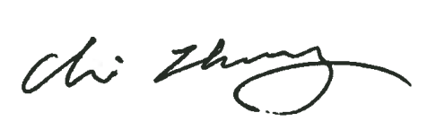

Chi Zhang, Ph.D.

Associate Professor Department of Medical and Molecular Genetics,

Center for Computational Biology and Bioinformatics,

Indiana University, School of Medicine

410 W. 10th St, Suite 5000, Indianapolis, IN, 46202